The Right Recipe
“Eat right.”
Each day, nutritionists, dietitians and diet doctors dish out this well-intended advice to clients, patients and those seeking the right way to reduce bodyfat and improve health.
Unfortunately, the well-intended admonition “eat right” has become a very obscure and ambiguous “prescription.” I receive so many letters and emails from people who are confused about what it really means to eat right. “Is that low carb? Is that low fat? Does that mean joining a weight-loss clinic? What, when and how do I eat to ‘eat right’?”
Good news: There is an answer. I call it the “Right Recipe.” It has four primary ingredients. Each plays an important role in the overall process. I’m going to teach you about each of these ingredients. Then I’ll go on to explain how they all work together.
So, if you’re ready to learn what it really means to “eat right” once and for all, you're in the right place.

The Right Recipe Ingredients
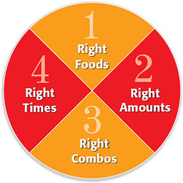
As you can see in the “pie chart” above, the four primary ingredients are: the Right Foods, the Right Amounts, the Right Combos and the Right Times.
That’s it. That’s all there is to it. When you combine these four ingredients, you absolutely, positively will have the Right Recipe to feed your body in a balanced, healthy, hearty, satisfying and effective way. You’ll be able to gain energy, build strength, look and feel younger and reduce bodyfat.
As I walk you through an explanation of each ingredient in the Right Recipe, rest assured, I will not drag you through a complicated, convoluted and overly detailed dissertation of the many idiosyncrasies and trivialities of nutritional biochemistry. That’s not my style.
As I see it, my job is to do the reading, the research, the reviews, then separate the wheat from the chaff, trim the fat and simply serve you the basic bottom-line facts. And that’s what you’ll find here.
That said, let’s get down to business… let’s learn what we need to know about the four ingredients that form the Right Recipe of the Eating for Lifestyle.

INGREDIENT #1: The Right Foods
The foundation of your success with Eating for Life begins with knowing which foods are right for you—which ones provide the high quality, essential nutrition your body needs. In my book Body-for-LIFE, I called these the “authorized” foods, which are the ones that are okay to include in each of your daily meals. These foods get the green light because of the amount of nutrients they contain compared to calories. The best foods offer the most nutrients per calories. The technical term for these right foods is “nutrient rich and calorie compact.” That is the opposite of “empty calories” or “wrong foods,” which means they contain calories but little nutrition.
Right foods are healthy sources of the six nutrients that are essential to great health: protein, carbohydrates, essential fats, vitamins, minerals and water.
Just as every single one of the ingredients listed in each of the 150 very delicious and nutritious Eating for Life recipes featured in this book are absolutely essential for the meals to turn out right, the same is true in regard to these six essential nutrients and you. In order for you to “come out right”—in order for your mind to think clearly, your muscles to maintain strength, your body to metabolize fat efficiently and for you to enjoy great health and energy—you must feed your body the right foods, rich with ample amounts of essential nutrients.
Consider this statistic: Your body is made up of well over 75 trillion (75,000,000,000,000) cells.
Mind boggling, isn’t it?
So is this: Within a year, each and every one of those cells will be completely gone. It’s true!
You see, just as sure as the earth is revolving at this very moment, so too are our bodies—they’re always moving, cycling and “recreating.” Life (yours, mine and everyone else’s) is in a constant state of motion, even when you’re just sitting there!
As sure as you’re reading these words on this page, right now, each and every one of those 75 trillion cells is degenerating and regenerating. For example, our entire skin is “recreated” approximately every four weeks; our skeleton every three months; and our blood supply every four months. Every second of every minute of every day, your cells and mine are completely transforming.
Now, for this process to proceed in a healthy way—for all those new cells to be recreated the right way—it’s vitally important that all the right raw materials and the essential nutrients are available when and where they are needed.
Problem is, far too many Americans aren’t getting nearly enough of these nutrients. Scientific research shows most people are low on water, dangerously deficient in essential fats, undersupplied in quality protein and malnourished in many vitamins and minerals. This is not good. You see, even when nutrient deficiencies exist, new cells will still be created. Your body will do the best it can, in spite of the missing ingredients. The body is brilliant, and it can adjust and adapt to so many circumstances. But when it is starved of essential nutrients, day after day, its ability to recreate cells the right way becomes crippled. Over time, as your body’s cells become unhealthy, so will you.
The signs and symptoms of this serious problem are often ignored: low energy, depression, insomnia, aches and pains and constant cravings for “something.” The “new” you being created is an unhealthier version each and every day. But it doesn’t have to be that way!
By eating right, you can feed the recreation process and actually become a healthier new you beginning now and continuing far into the future. That’s why eating the right foods that provide your body with all the essential nutrients it needs to keep the recreation process going strong is so important.
Here’s some essential information about essential nutrients you need to know before we go on to the next ingredient of the Right Recipe.

Protein
Protein is included in each Eating for Life meal, for good reason. It is an essential component of every one of those 75 trillion cells our bodies are made of. Protein is a very important nutrient; in fact, the word itself originates from the Greek word meaning “of prime importance.”
Some of the very high quality protein rich foods that are ingredients in Eating for Life meals featured in this book include: chicken breast, turkey breast, lean beef, swordfish, orange roughy, salmon, tuna, crab, lobster, shrimp, lean ground beef, buffalo, eggs, cottage cheese, lowfat cheese, nutrition shakes and protein powder.
All of these foods offer complete proteins, which contain all nine of the essential amino acids: histidine, isoleucine, leucine, lysine, methionine, phenylalanine, threonine, tryptophan and valine. (By the way, knowing the essential amino acids by name, plus 2 bucks, will get you a cup of coffee at Starbucks!) The reason these amino acids are “essential” is because your body can’t make them on its own, so they must be provided through the foods we eat.
The amino acids, derived from quality complete proteins, are the basic building blocks of muscle as well as a countless number of enzymes, hormones, neurotransmitters and antibodies. Also, when you eat meals containing quality protein, it supports your metabolism, helps stabilize energy levels through its effect on insulin and blood sugar and satisfies your appetite.
Now, although protein is of prime importance, it is only one of the six essential nutrients. And despite the proclamations of protein powder pushers, it is not in and of itself the panacea—it is not the “one key” that opens the door to increased muscle, health, strength and vibrancy.
Variety is as important as anything when it comes to protein. That’s why I eat some chicken. I eat some turkey. I eat some beef. I eat some cottage cheese. And I eat eggs. And I drink my nutrition shakes, which are fortified with proteins derived from soy sources as well as whey.
The bottom line is, the right protein is not derived from just one source.
Your body craves, intuitively, instinctively and very, very intelligently, a lot of sources of protein. Feed it, don’t fight it. And, don’t let protein pushers, who proclaim the power of their “source” to be superior to any other, to persuade and override your intuition.
The power of protein is in the variety, the satiety, the health enhancing, muscle strengthening effects, which are best derived from feeding your body with as many different quality right proteins as possible.

Carbohydrates
Carbohydrates, like protein, are essential to your health and are also included in Eating for Life meals. Among the foods that provide quality carbohydrates you’ll find included in the 150 Eating for Life meal recipes are: brown rice, oatmeal, potatoes, yams, pasta, barley, apples, berries, oranges, wholegrain breads and pitas.
Carbohydrates are first and foremost a source of immediate energy for all of your body’s trillions of cells. Carbohydrates also cause the release of insulin, a powerful hormone needed to help amino acids enter cells, which is very important. In that way, carbohydrates and protein work together, which is one of the many reasons I have included both in every meal.
In recent years, there has been a great deal of discussion and debate, amongst the diet doctors in particular, about the eminent evils of eating carbohydrates. And although I agree that the food supply in America, in particular that fast-food frenzy which I talked about in Chapter 2, is serving us a surplus of crummy carbs, that does not, I repeat NOT, mean that all carbohydrates are bad for you.
Other “experts” have alleged that you can draw the line between “good carb” and “bad carb” sources depending on whether they are refined, processed or what their score is on a scale called the “glycemic index.” Once again, although I believe there is a morsel of truth to this, I don’t think it’s as literal—as black and white—as these diet doctors make it out to be.
For example, on several of the very popular lowcarb diets, the authors fight that fruits, such as apples, are actually bad for you.
Come on… that’s just silly!
If you have your nose stuffed so far up the scientific literature and lab reports that you determine something as natural, healthy and wholesome as an apple is to be a condemned carb and blamed for being part of America’s big fat problem, then you have simply lost touch with reality!
Make no mistake, I am not going to tell you there are merely good and bad carbs and that they can be determined by a lab test, judging how fast or slow they are digested, how much or how little they, on their own, cause your body’s blood sugar to rise and fall, and how much insulin levels are affected as a result.
The fact is, in the real world things don’t work just like they do in the scientific laboratories. In the real world, I know for certain that what works, long term, is eating a variety of carbohydrates. And that’s why I eat some brown rice, barley and oatmeal, which cause a relatively slow, steady release of blood sugar into my body. And I also eat ample amounts of apples, oranges, berries and other foods that contain carbs that provide quicker energy. But variety is the key!
This approach works! I’m living proof.
You know this already, intuitively. It’s that common sense I’ve been talking about throughout this book. It’s that natural intelligence we have inherited from our longlost ancestors. We naturally reach for brightly colored fruits, which have been “kissed” by the sun and which literally contain particles of light energy, phytonutrients, as well as numerous vitamins and minerals, along with energyrich carbohydrates.
Fact is, I recommend right carbs based on many factors, not simply on how fast they do or don’t cause your blood sugar to rise or what their glycemic index is. For example, the carbohydrate foods that are included in the recipes featured in this book are there because they are nutrient rich. This not only makes them good for you, but it makes them taste good too.
You see, “good taste” is something we are all born with; something we inherited. And the desire to taste delicious, sweet and soft fruit is, once again, something we should feed and not fight.
So the bottom line is, the right carbs to eat for life include a vast variety and are not just selected solely on whether they are good or bad, quick or slow. Such classifications have been greatly exaggerated; they are counterintuitive and make the issue of carbs complex when, naturally, they should be a source of simple, sweet satisfaction.

Essential Fats
That’s right, essential fats. I know that might sound and seem a little strange—the idea that any form of fat could be essential is quite foreign to most. For certain, the fact that fat fortifies and nourishes those 75 trillion cells within our bodies has been very well established for over 40 years. Unfortunately, that message has been lost in the marketing and media hype, which would have us believe bodyfat is simply a form of consumed fat from foods. Fact is, that is not so!
Bodyfat, that extra flub on your belly and buns, is not just there because you ate food with fat in it. The buildup of bodyfat is always a result of not following the Right Recipe. It’s not simply a matter of eating something with fat in it. In fact, it’s an established scientific certainty that the right fats, the essential fats, increase the metabolism of stored bodyfat and decrease fat production in the body.
So how could fat be essential in any way? It’s because cell membranes, hormones, antibodies and enzymes all must have the “raw material” of certain essential fats in order for our DNA, our genetic blueprint, to fulfill its destiny and recreate the new you, the best you can be.
If you’re malnourished in essential fats, which research shows over 95 percent of all Americans are, this process is compromised and certain deficiency symptoms begin to manifest themselves: dry skin, a depressed metabolism, mood disorders, decreased energy, dizziness and even memory loss.
You certainly don’t need to know everything about the essential fats. Just remember that they, like the other nutrients included in Eating for Life meals featured in this book, are there for important reasons. Not just for flavor but because they are good for your health.
There are two particular types of essential fats in Eating for Life meals. These are ones that cannot be made by the body but are necessary for thousands of biochemical reactions to take place. These essential fats are called linoleic acid (sometimes called an omega6 fatty acid) and linolenic acid (omega3). In the ideal metabolism, linoleic and linolenic acid are the only dietary fats you need. These are found in healthy vegetable oils (canola oil, olive oil, safflower oil), fish oils (good fats in salmon, tuna, halibut, etc.) and in dark green leafy vegetables, such as spinach. As long as you’re eating ample amounts of these right foods every week, you will be getting the essential fats you need.
Now, there are right fats, and there are some wrong fats. Those which are bad for you include the saturated fats and the true dietary devil, trans fats, which are found in sick amounts in margarines, crackers, cookies and fastfood fries, burgers and so on. These fats have been proven to cause diseases ranging from cancer to diabetes to heart disease. They also are the fats that are the most likely to make you fat! We certainly want to avoid those fats, at least most of the time.
So the bottom line is, be sure to eat the essential fats your body needs in forms and foods such as healthy vegetable oils; fresh fish like salmon, albacore tuna and halibut; as well as dark green leafy vegetables, such as spinach. That’s what I do, and it works for me!

Vitamins and Minerals
All three of the nutrients I’ve talked about so far—proteins, carbohydrates and essential fats—need to be consumed daily in relatively significant quantities that are measured in ounces or grams. Scientists call these “macronutrients” (macro meaning large).
The other essential nutrients I’m going to tell you about now are consumed in very small quantities (often measured in milligrams). They’re known as the “micronutrients” (micro meaning small). These are the vitamins and minerals. Although only small amounts of these nutrients are needed by the body, they serve a very important role in maintaining the proper biological functioning of everything from your muscles to your mind. Vitamins and minerals contribute to good health, muscle growth and proper fat burning by regulating the metabolism and assisting the biochemical processes that release and recharge energy from the food you eat. If you don’t eat enough of these essential micronutrients to maintain proper levels, deficiency symptoms, which include muscle weakness, slow fat loss, connective tissue deterioration and frequent colds and infections due to suppression of the immune system, just to name a few, will appear.
Vitamins are “organic” compounds, which means that they are produced naturally in both vegetables and animals, where they are found in abundant quantities. The main function of vitamins in the body is to help enzymes with reactions, including energy metabolism, protein synthesis, nutrient digestion and absorption, to name but a few of thousands of processes. Vitamins are essential—you cannot live without them. Literally.
Vitamins are either fat soluble or water soluble, depending on whether fator water based molecules transport the vitamins through the bloodstream. Fat soluble vitamins include A, D, E and K. Because these vitamins have an affinity for fat, they can be stored in both adipose (fat) tissue and in the liver, extending their effective life span in the body and strongly decreasing the chance of developing deficiencies. The watersoluble vitamins include all of the B vitamins and vitamin C; they aren’t stored in the body for more than a few hours, so daily intake is a must.
Minerals are inorganic in nature, meaning they are not produced by plants or animals. They can, however, be found in food sources, for example, iron in red meat, calcium in milk and potassium in bananas. Minerals are extremely important for your body to work right. They are essential for nerve cell communication, flexing muscles, fluid balance and energy production. Many minerals also serve as building blocks for body tissues, such as calcium and phosphorus for bones.
Minerals are referred to as either “bulk” or “trace” depending on the amount needed by the body. Bulk minerals include calcium, magnesium, potassium and sodium. Trace minerals, on the other hand, may be required in quantities as little as a few micrograms (that’s just one onethousandth of a milligram). These include minerals such as chromium, copper, iodine and selenium.
Within the Eating for Life meal recipes, you’ll find vast amounts of vitamins and minerals in the form of fruits and vegetables, such as apples oranges, tomatoes, bananas, berries, broccoli and spinach. Also, right carbohydrates and proteins—whole grains, lean beef, chicken and nutrition shakes—provide rich sources of essential micronutrients.

Water
Water is so important to good health—consuming ample amounts is absolutely essential for fueling health and energy. Water covers approximately 70 percent of the earth’s surface and makes up over 70 percent of our bodies as well. All living things rely on water to thrive, you and I included. It helps produce energy, detoxify our bodies, regulate body temperature, build new cells and lubricate joints, among thousands of other functions.
We naturally lose water every minute of every day, just through breathing. During the summer months, water losses are greater because body perspiration, which is used to cool our systems, evaporates faster in a hot environment. Caffeinated and alcoholic beverages are diuretics—they cause you to lose even more body water.
We generally lose about 10 cups of water per day. Unfortunately, most Americans, research shows, don’t drink nearly that much. Consequently, many people are walking around in a chronic state of dehydration, which is not good to say the least. Water losses of one percent of your total bodyweight can impair functioning both mentally and physically. Losses of four percent can cause headaches, loss of energy, muscle weakness and irritability. Losses of seven percent can be fatal. Serious? You better believe it is! But it is easily prevented.
Don’t wait until you’re thirsty to drink water, or you’ll give back less than what you really need. It is essential that you replenish your water losses daily.
It’s not a discussion topic for good company, but watching your urine may be the best way to tell if your body’s properly hydrated. Dark, gold colored urine is a sure sign you’re low on fluids. Drink enough water to aim for light yellow or, better yet, almost clear urine. The average person needs at least 10 cups of water per day. People who exercise regularly need even more. I drink water from dawn to dusk and then some. I drink 16 ounces of bottled or filtered water first thing in the morning and another 16 ounces during my workouts. All total, I drink almost a gallon of water each and every day, and I drink an extra cup of water for each cup of coffee or diet soda I drink during the day. I suggest you do the same.

INGREDIENT #2: The Right Amounts
Now that you know which foods are right—which ones are high in nutrients, convenient and taste good—it’s time to move on and discover the right amounts of the right foods you should eat in each meal.
Fortunately, you don’t have to become a calorie counter nor do you need to meticulously monitor the carbs or fat grams of each and every food to know if you’re eating the right amount. What works well is to gain an understanding of the importance of portions.
You don’t need to get out a calculator to figure out if you’re on target with the right portions of right foods included in each Eating for Life meal. In fact, the information you need to know is transmitted to you at 186,000 miles per second! That’s the speed of light. And that’s how fast the answer to the question, “Is this the right amount of food for me?” is reflected.
So what is a portion?
Well, a portion is an amount of right protein roughly equal to the size of the palm of your hand. For example, a chicken breast about the size of the palm of your hand is a proper portion of chicken for you.
A portion of a right carbohydrate is an amount roughly equal to the size of your clenched fist. For example, a baked potato about that size is the right amount for you.
The right amount of a serving of vegetables is approximately what you might imagine you can hold in the cupped palm of your hand. For example, a portion of steamed broccoli could be a little or a lot, depending on your appetite, really. You see, with vegetables, like those included in the Eating for Life meal recipes in this book, you have a lot of leeway—you don’t have to limit yourself to a certain amount, and you certainly don’t have to forcefeed yourself a certain serving size.
What I do, generally, is eat a portion of protein and a portion of carbohydrates in each of my daily meals, and in two of these meals, I include a serving of vegetables (my favorites are broccoli, steamed spinach and zucchini). Sometimes I’ll eat a little serving of vegetables, and sometimes a lot, depending on my appetite… depending on what I’m intuitively craving. Once you too begin the Eating for Life style, you’ll get the hang of it.
Eating the right amounts of the right foods in each meal is important. I’ve discovered that people eat too little amounts just as often as they do too much. The critical component is eating the right amounts of the right foods. When you do this, you become more connected with what a satisfying meal actually feels like. You’re not hungry or stuffed. Your appetite and cravings are satisfied. Your energy is fed.
Be forewarned: Eating too little or overeating the right or wrong foods in one meal will throw your energy off for hours later in the day. For example, eating too little for breakfast may manifest in overeating dinner or dessert. And the contrary… a breakfast binge may mean missing midmeals and abruptly interrupting energy, as well as physical and mental performance throughout the day. When I say eating the right amounts of the right foods is vitally important to your success with the Eating for Lifestyle, I’m not kidding at all!
And, as I’ve already explained, eating the right amounts is not complicated or inconvenient. You just must simply know what to do!

INGREDIENT #3: The Right Combos
Now that you know about the right foods and the right amounts, it’s vitally important to understand the right combinations.
Quite simply, what you do is choose a portion of protein and carbs, and include that in each of your Eating for Life meals. For example, chicken breast (protein) and brown rice (carbohydrate). And in at least two of your daily meals, include a portion of vegetables. An example of this would be a dinner with a chicken breast, brown rice and broccoli. Throughout the 150 meal recipes featured in this book, you’ll see an array of ways to combine protein, carbohydrates and vegetables.
Combining the right foods in the right amounts not only calms your cravings, but it also helps feed your muscles by providing both the amino acids from protein, along with carbohydrates, which help “shuttle” that protein into cells. Scientific studies and real world results reveal that eating a portion of protein along with the right amount of carbs provides a synergistic effect—carbs help protein fulfill its destiny, so to speak.
Rest assured, the Right Recipe ingredient of combining protein and carbs in each meal is based on sound, scientific research. For example, in a recent study published in the Journal of Nutrition, researchers found that balancing protein and carbohydrates stabilizes blood sugar and insulin (the purported benefits of the lowcarb diets) and tended to decrease bodyfat, cholesterol and reduce the risk of type 2 diabetes.
In another study reported last year in the journal Physiology and Behavior, a team of Swiss researchers reported that by balancing protein and carbs in each meal, you could benefit not only your muscles but your mind. Balanced eaters experienced better overall cognitive/mental performance compared to test subjects who ate meals that were not balanced.
In yet another study published in the European Journal of Clinical Nutrition, scientists cited, once again, that eating a balance of protein and carbohydrates and essential fats in each meal resulted in greater feelings of energy and lower levels of fatigue. They determined that balanced meals promote stable energy and greater endurance.
In another scientific study, this one published in the journal; Medicine and Science in Sports and Exercise, researchers reported that in test subjects who exercise, consuming a post workout meal with both protein and carbohydrates resulted in better moods—enhanced feelings of strength and confidence. That’s good news because the more optimistic you are, the more likely it is you will continue to eat right!
More proof for the pudding: Scientists have also shown that people who eat a balance of protein and carbohydrates have better digestion and absorption of nutrients and a higher “thermic effect” (fatburning effect) from each meal. On top of all that, studies show that meals balanced in protein, carbohydrates and essential fats help people like you and me control our appetite.
I could go on and on, but rest assured, the results of research in the realm of traditional science, as well as reams of realworld results, absolutely and positively support the Eating for Life recommendation of combining protein and carbohydrates in each meal. This advice, although it goes against the grain of the popular low-carb diet dogma, provides a basic, balanced and in my opinion the best approach to making the most of each and every meal.

INGREDIENT #4: The Right Times
Okay… now you know that eating the right foods, in the right amounts, in the right combinations are three of the essential ingredients in the Right Recipe. And the fourth and final ingredient, that’s eating at the right times.
Q: What are the right times?
A: Six times a day is the right way!
It’s true!
What about the old adage that “three square meals a day” is best?
Well, that nonsense is not based on anything even remotely related to good health or sound nutrition. The expression “three squares” comes from centuries ago when serving crew aboard warships gave the gunners three daily meals served on square wooden platters—meals that consisted of salty, half rotten meat and crusty old biscuits. I think you also get three square meals a day in county jail, but I don’t know for sure.
Anyway, the fact of the matter is, your body, my body, everybody’s body works better when we eat the right foods, in the right amounts, in the right combos, not three but six times per day.
Eating six meals a day creates a “metabolic environment” that supports your energy and muscle metabolism, while helping you burn bodyfat. Study after scientific study has shown this to be so. For example, a recently published report in the European Journal of Clinical Nutrition cites that people who ate six times a day had a faster resting metabolic rate than those who ate just three meals daily. As you may very well know, your metabolic rate is the pace at which your body burns fat and food energy to keep you going strong. This study showed eating meals frequently throughout the day allows you to burn fat more efficiently. That’s good!
Researchers at Georgia State University recently arrived at the same conclusion. They found that those who ate just “three squares” a day had, on average, a higher percentage of bodyfat than those who ate six times per day, leading the researchers to cite that the idea of eating three square meals is best is downright wrong. (I agree, by the way!)
Another way eating six complete meals a day helps you lose bodyfat is by allowing you to maintain lean muscle. Remember, muscle not only helps you look leaner but also makes your body more metabolically active. Muscle burns calories even when you are just sitting there. Fat does not.
Numerous studies have shown that eating frequent meals increases fat loss while helping you keep your muscle. One recent report studied physically active people who ate the same amount of food each day but in a different number of meals. The people who ate only two meals a day lost about twice the muscle and half the fat as the people who ate six meals a day. In other words, the weight lost by those eating six meals was primarily bodyfat, while those eating just two meals lost mostly muscle.
When you eat meals every few hours, you’ll have more energy; you’ll also have less hunger and cravings, as was demonstrated in yet another recent study where it was shown that people who ate two large meals a day, given the same food choices as those eating six meals a day, consumed an average of 27 percent more food.
As I see it, eating one big meal causes your blood sugar to spike, then crash. Research shows that this “nosedive” in your blood sugar strongly stimulates hunger. So at your next meal, you’re more likely to get to the table ravenously hungry, which, of course, can cause you to eat too much. But with six balanced meals per day, you never get to that point of ravenous hunger. At meal time you feel a little hungry; then you eat; you feel full—you feel satisfied until your next meal.
Another study published recently in The New England Journal of Medicine showed that in as little as two weeks, people who ate frequent, portioncontrolled meals as opposed to three large meals (containing the same total amount of food) reduced their “bad” cholesterol levels by nearly 15 percent, reduced their cortisol levels (the “stress” hormone that contributes to belly flab and many other side effects) by more than 17 percent and reduced insulin levels by almost 28 percent.
There’s more… a scientific study reported in The European Journal of Clinical Nutrition shows that eating “compact,” balanced, nutritious meals every two to three hours throughout the day increases your metabolism, allowing you to burn more fat. When your daily food intake is eaten in a small number of large meals, there is an increased chance to become overweight.
Yet another study revealed that eating often helps your blood sugar and insulin levels stay strong and steady. When insulin levels spike, fat storage starts, blood sugar drops and energy levels plummet. Six meals per day do away with the highs and lows of blood sugar and insulin, as demonstrated in a recent study which clearly shows blood sugar remains much more constant and insulin levels stayed much lower in the sixmealaday group than in the two meal group. That’s good.
I could go on and on. Another study published in the International Journal of Obesity and Related Metabolic Disorders found that when you eat frequent meals throughout the day, it helps control the appetite.
Again, a study published in the American Journal of Clinical Nutrition reported that people are most successful at losing fat and keeping it off when they eat numerous meals throughout the day.
Had enough?
I have!
The bottom line is, when you eat every few hours, when you work with your body instead of against it, you’ll not only look better but I’m certain you’ll just flat out feel better too… a lot better.

Right Recipe Wrapup
So there you have it—the Right Recipe. What it really all boils down to is this: When you eat the right foods, in the right amounts, in the right combos, at the right times, you simply cannot go wrong!
Join the open discussion about NUTRITION in the forums.

Have Fun and Feel Free
Now that you've learned the specifics of Eating for Life and you know about the right foods, right amounts, right combinations and the right times to eat, here's what I want you to do next...
Forget all that stuff!
That's right, put it out of your mind. Not every day. Just one day a week.
Let me explain...
I've discovered that the healthiest people, with the healthiest eating habits, enjoy eating "fun foods" that are not necessarily the most nutritious, from time to time. I'm the same way. And so I have designed the Eating for Lifestyle to accommodate this natural pattern. Blending both common sense and science in a way that makes Eating for Life even more effective and enjoyable.
So what I'm asking you to do is to follow the Eating for Lifestyle, as I've described in this book, six days a week. And on the seventh day, I ask that you eat whatever you want, whenever you want, in whatever amount and combination you so desire. I call this your "free day."
On that one day a week, if you want to eat waffles with whipped cream, all covered in maple syrup for breakfast, that's fine. If you crave lasagna and bread with butter for lunch, go for it. If you want a thick pepperoni pizza with double cheese for dinner, be my guest. A piece of apple pie with ice cream for dessert... sounds good to me!
Do this and don't worry about it, please.
There are two physiological benefits to purposely eating extra once a week: It boosts fat burning and it helps you control your appetite. You see, when you make a significant change in your eating habits and cut out the junk food, the saturated fat and the high amounts of sugar, it may set off that thousand-year-old encoded alarm inside your brain - the one telling you to eat more. (Remember, way back when, those who could eat the most food, the fastest, and store the most bodyfat were the most "fit to survive" during that era.)
Sensing the change and not knowing that there isn't a famine around the corner, your body may begin to limit production of a hormone called "leptin." Leptin is one of many feedback systems your body needed to help keep it from starving in the old, old days. Strong leptin production equals a strong metabolism. Diminished leptin production, on the other hand, makes your metabolism go down and your appetite go up. That is not what we want!
Knowing that science shows the more leptin levels fall, the more your appetite rises and also being aware that response is forged from tens of thousands of years of evolution, we can be certain it's better to feed it than fight it. When you do, a message moves from your belly to your brain and says, "It's all good!" In a nutshell, this is how and why eating extra once a week stimulates your metabolism, supporting your efforts to lose unhealthy bodyfat, while it also helps you gain control over cravings.
Now, there are also numerous psychological benefits to the free day. For starters, people find they can live without some of their old favorites like unhealthy desserts, candy bars and burgers and fries most of the time if they know they can eat them some of the time. This really helps people stay on track and keep a positive mindset. And that is so important. No one wants to play a game he or she can't win. You don't want to set yourself up for failure. You don't want to create standards you can't meet. If you say, "I'm not going to eat another chocolate chip cookie from now on," and if you happen to like chocolate chip cookies, well, then you're setting the table for failure, so to speak. So let's not do that, okay?
Another benefit of the free day is that it creates freedom. Freedom from unrealistic rules, as well as freedom to make decisions for yourself. That's important because I've discovered most people are willing to draw some lines and create a framework for their eating, as long as there's an element of freedom that remains. And so I don't tell you what to eat... you decide for yourself. Even on your six Eating for Life days of the week you decide what to eat.
The free day also helps create openness, honesty and self-respect. You see, all healthy people have needs and cravings that should be expressed, not suppressed. Everyone I've ever met has a few "favorite foods." For me, it's double-cheese pepperoni pizza, Krispy Kreme doughnuts (the glazed ones) and carrot cake with rich cream cheese frosting. For others, it's fries and cheeseburgers or ice cream and chocolate. And for others, it's something altogether different.
Each person has his or her own favorites. Some remind them of warm moments from their childhood. Other favorites are driven by identity, region, heredity and gender. Anyway, I encourage you to eat some of your favorite foods on your free day, even if they are not highly nutritious. This advice goes against the grain of today's popular diet dogma, which makes eating those foods completely off limits and creates rather than resolves problems.
What I've noticed is people on diets "sneak eat" their favorite foods, and when they do, they often serve up a side dish of shame and a tall glass of guilt. This is unnecessary. With Eating for Life, no foods are forbidden.
None! Some we only indulge in once a week, but we never say never... ever!
So please, don't deny that you have favorite fun foods, and don't pretend that your appetite for those foods is nonexistent. When you stuff those cravings down, look out! They may manifest in the most unusual places! Make no mistake, it's best to eat some of your favorite foods once a week.
It's healthy, natural and normal.
Got it? Good!
Okay, now there are two types of free days: planned and unplanned.
An example of a planned free day, for me, is if I know I'm going to a Denver Broncos football game on Sunday with my brother and we intend to "get into it" and eat hot dogs, nachos, those giant pretzels and hope for overtime so we have time for popcorn and peanut M&M's as well. As far as when you should plan your free day, that's up to you. Some set aside every Sunday to eat whatever they want. Your free day doesn't have to be the same day every week. Oftentimes, you might plan it for a special occasion. For example, Thanksgiving - there's no question, that's a free day on my calendar. So is my birthday. I don't know about you, but I really like the tradition of eating birthday cake. (I love German chocolate cake with coconut frosting!) I think most people do. It's fun, and it feels good. (By the way, what do people who follow a low-carb diet all the time eat on their birthday... a brick of Brie with bacon and candles on it? Yuck. And boring.)
Here's an example of an unplanned free day: On my last trip to New York, I got stuck at the airport with a delayed flight, missed two meals and arrived at the hotel after a long day to find they didn't clean out the "mini bar" like I asked them to ahead of time. Fatigue and hunger took over for a few minutes, and I lost "full awareness." When I came back to, I found a pile of crumbs and a few empty bags of Chips Ahoy and Oreo cookies, along with one-half of a broken Pringle sitting in the bottom of the can. Oops! Hey, it happens. Fortunately, not all that often. But when it does, I go to my journal and simply cross out my Eating for Life plans for the day and write "FREE DAY!" Then, if I was planning for a free day on Sunday, I simply follow the Eating for Lifestyle that day instead. Follow me?
This is how to utilize the free day when, despite your best efforts, your day doesn't go as planned and you end up eating wrong. This helps add flexibility and practicality to Eating for Life. Remember, it's what you eat most of the time, not some of the time, that feeds success.
Having had the opportunity to help so many thousands of people begin Eating for Life, I've noticed that, at first, their free days become feasts. However, what they discover is when you eat right, six days a week, and then you pig out once a week, I mean really go for it, it hurts. Stomachaches are the rule, rarely the exception. And this becomes a learning experience. Psychologists call it "aversion therapy." Kind of like when parents catch their kids with a pack of cigarettes, which they might puff on at school to try to look cool, and the parents actually "make them" smoke a few. They turn a little green, become just ill enough that cigarettes no longer seem cool; in fact, they seem disgusting.
And this is why free days tend to become self-regulating, self-limiting and part of the overall solution, not part of the problem. They teach you to manage your food intake. And this is something I point out to those who initially are concerned that their free days will be so out of control, it will cause them to gain fat, even if their six Eating for Life days are right on track. I haven't seen that become a real issue, long term. So don't worry about it. Even I've learned there are only so many Krispy Kreme doughnuts I can eat before I make myself absolutely, positively sick and sorry. You will too!
Some people find that on their free days they have one big meal, like a brunch with pancakes, an omelet, bacon and orange juice, and then they don't feel like eating the rest of the day. That's fine. You don't have to forcefeed yourself. The point is to eat what you want. No more, no less. It's your free day. Do what you wish. If you eat a big lunch and don't feel like eating a big dinner, that's okay.
I've also discovered that free days help remind you of what it was like when every day was free day, so you are aware of what you're getting away from - the ill feeling and the energy drain created by overeating.
By the way, the afternoon of your free day is a great time to do your grocery shopping for the upcoming week. Your appetite will be completely satisfied, so the urge to buy tempting but unhealthy foods will be stuffed.
Another thing you will discover is that as you begin to learn how to plan, prepare and cook many of the Eating for Life meals that are featured in this book, you'll find yourself enjoying new favorite foods that are healthy and balanced with protein and carbohydrates. For example, sometimes on my free days, I'll eat Chicken Enchiladas (page 114) or Spaghetti and Meatballs (page 89), and my "freedom" is expressed by simply serving seconds, sometimes even thirds. I'll eat a little more of these healthy foods for fun, for satisfaction. But I don't make myself sick to my stomach, like I used to when free day meant a free-for-all.
With Eating for Life, I never feel like I'm sacrificing or suffering or starving. And I'm never bored. I enjoy eating right six days a week, and I also enjoy eating my favorite fun foods every week. And I am able to stay healthy and strong.
The free day has been one of the keys to my maintaining this approach for over a decade. It's not something I do for just a certain amount of time. It's my lifestyle. And I think it will be for you as well.
The important thing to remember is that your free day is yours. Have fun with it and feel free to be yourself. And, please, feel right about it because, in more ways than one, it's good for you!

Daily Nutrition Worksheet
Few things can improve your life more than making the change from unhealthy eating habits to a smart, healthy and sustained approach to nutrition. Essential to making that change is learning to thoughtfully plan what you're going to eat ahead of time. When we do this, for example the night before, or even planning a whole week in advance, we simply take the guesswork out of it. No longer do we wait until we're hungry and then haphazardly look for something to eat for breakfast, lunch or mid-afternoon. We go about our day and follow the plan.
The worksheet you'll see on this page helps you both plan your daily nutrition and carefully keep track of two key things: First, I want you to pay particular attention to the portion sizes you're eating at each meal. And so I ask you for each meal to simply give me a 'Yes' or 'No' to the question, 'Did you eat the right portions in this meal?' By doing this regularly you'll develop a precise and automatic thought process which will course-correct you gently and efficiently when you're portion sizes get too big.
Next, this Worksheet allows you to journal how you feel after each meal. If you eat too much, you might feel guilty, heavy, too full. When you eat the Right Amount you'll feel healthy, satisfied, good. By regularly checking in with your feelings after a meal, you'll develop a very keen awareness over time about the connection between your emotions, mindset and how you're eating. This in turn helps you internalize and own what you're learning so that you develop a real sense of nutritional wisdom. All that leads to better and sustainable results, which is one of the primary goals of this transformation experience.

Sunny Side Up
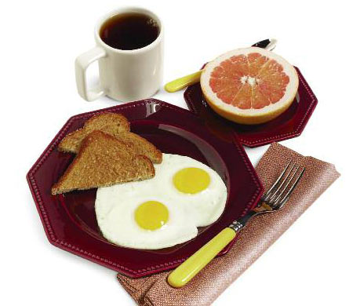
Bright and basic morning meal!
Servings: 1
Preparation Time: 10 minutes
INGREDIENTS
1 egg white
2 whole eggs
1 slice whole-grain bread, toasted
1⁄2 grapefruit, sectioned
DIRECTIONS
- Lightly coat a small nonstick skillet with cooking spray and place over medium heat.
- Add egg white and whole eggs to skillet; cover and cook until whites are set and yolks have thickened, about 3 minutes.
- Slide eggs onto warmed plate with toast. Serve with grapefruit half, a hot cup of coffee and enjoy!

Blueberry Blend
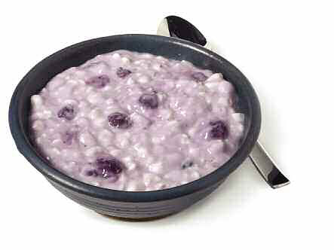
Protein-rich cottage cheese with blueberry yogurt
Servings:
Preparation Time: 2 minutes
INGREDIENTS
1 portion low-fat cottage cheese (about 1⁄2 cup)
1 portion light, fat-free blueberry yogurt (about 6 oz)
DIRECTIONS
- In a serving bowl, combine cottage cheese and blueberry yogurt.
- Serve and enjoy!

Eggs and Oats
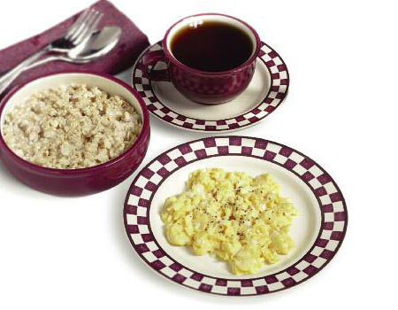
Simple and nutritious way to start your day
Servings: 1
Preparation Time: 10 minutes
INGREDIENTS
½ cup whole-grain oats (non-instant)
1 whole egg
3 egg whites
ground black pepper, to taste
½ cup skim milk
sugar substitute, to taste
DIRECTIONS
- Cook whole-grain oats according to package directions.
- Lightly coat a small nonstick skillet with cooking spray and place over medium heat.
- In a small mixing bowl, whisk the egg and egg whites until slightly frothy. Pour into skillet. As eggs begin to set, use a spatula to lift cooked portion. Cook until eggs are set, about 4 minutes.
- Place scrambled eggs on a small plate and top with pepper. Spoon cooked oats into a serving bowl, pour in milk and sprinkle with sugar substitute.
- Add a cup of coffee if you’d like. Serve and enjoy!

Golden Pancakes

Protein pancakes make breakfast a dessert!
Servings: 2
Preparation Time: 15 minutes
INGREDIENTS
1 cup uncooked whole-grain oats (non-instant)
6 egg whites
1 cup fat-free cottage cheese
1⁄4 tsp vanilla extract
1⁄4 tsp ground cinnamon
2 packets sugar substitute
DIRECTIONS
- Lightly coat a nonstick skillet or griddle with cooking spray; place over medium heat.
- In a blender, combine oats, egg whites, cottage cheese, vanilla, cinnamon and sugar substitute. Blend on medium speed until smooth, about 1 minute.
- Pour batter, about 1⁄4 cup at a time, onto hot skillet. Cook pancake until bubbly on top and dry around edges, about 3 minutes. Turn and cook other side until golden brown, about 2 more minutes.
- While pancakes are cooking, microwave maple syrup until warm, about 20 seconds.
- Place a portion of pancakes on 2 separate plates. Top
with warm maple syrup and mixed berries. Serve and enjoy!

Egg-Cellent Enchiladas

Quick, delicious, nutritious Eating for Lifestyle breakfast!
Servings: 1
Preparation Time: 8 minutes
INGREDIENTS
1 whole egg
3 egg whites
2 Tbsp reduced-fat cheddar cheese, shredded
2 corn tortillas
¼ avocado, sliced
¼ cup salsa, divided
DIRECTIONS
- Lightly coat a small nonstick skillet with cooking spray and place over medium heat.
- Whisk egg and egg whites until blended; pour into skillet and scramble for about 2 minutes. Add cheddar cheese and stir until eggs are set and cheese is melted, about 2 more minutes.
- Lightly dampen two paper towels and place the corn tortillas between them. Microwave on high for 30 seconds.
- Fill each tortilla with half the scrambled eggs and cheese, sliced avocado and a spoonful of salsa.
- Roll up, top with remaining salsa, serve and enjoy!

Denver Omelet

Delicious omelet filled with diced ham, bell pepper and onion with whole-wheat toast
Servings: 1
Preparation Time: 15 minutes
INGREDIENTS
1 whole egg
3 egg whites
1 Tbsp skim milk
¼ tsp ground black pepper
¼ green bell pepper, diced
¼ red bell pepper, diced
1 slice onion, chopped
¼ cup lean ham, diced
2 Tbsp reduced-fat cheddar cheese, shredded
1 slice whole-wheat bread
DIRECTIONS
- Lightly coat a small nonstick skillet with cooking spray; place over medium-low heat.
- In a small mixing bowl, whisk together the egg, egg whites, skim milk and black pepper. Pour egg mixture into skillet, cover and cook about 4 minutes until eggs are set but still moist.
- Spoon bell peppers, onion and ham onto half of the omelet. Fold omelet over filling and sprinkle with cheese. Cover and cook until filling is heated through and cheese starts to melt, about 2 minutes. Place omelet on a warmed serving plate.
- Toast wheat bread, serve and enjoy!

Chocolate Oatmeal
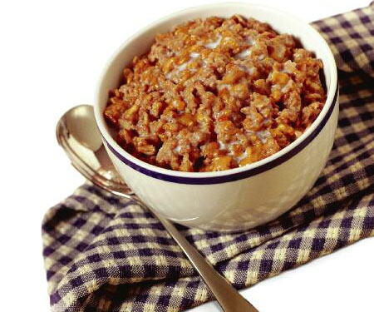
Old-fashioned oats, all-natural peanut butter with the added power of protein
Servings: 1
Preparation Time: 5 minutes
INGREDIENTS
⅓ cup uncooked whole-grain oats (non-instant)
½ cup water
1 packet chocolate Plus Protein (22 grams whey protein isolate)
Sugar substitute, to taste
½ cup skim milk
DIRECTIONS
- In a bowl, combine oats, water and protein powder. Microwave on high until oats are cooked, about 2 minutes.
- Stir in sugar substitute to taste.
- Pour milk on top. Serve and enjoy!

Turkey Sandwich
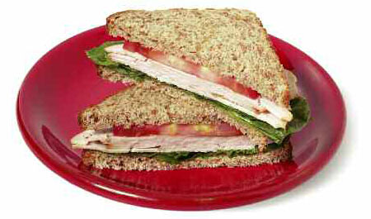
Roasted turkey breast, lettuce and tomato on fresh whole-grain bread
Servings: 1
Preparation Time: 5 minutes
INGREDIENTS
1 Tbsp mustard or fat-free mayonnaise
2 slices whole-grain bread
2 lettuce leaves
1 portion roasted turkey breast, sliced
½ tomato, sliced
DIRECTIONS
- Spread mustard or fat-free mayonnaise evenly over bread slices.
- Top one slice of bread with lettuce, turkey and tomato.
- Stack with the other slice of bread and then cut sandwich in half. Serve and enjoy!

Fortified French Toast

Protein-enriched French toast with vanilla, cinnamon and warm maple syrup
Servings: 1
Preparation Time: 10 minutes
INGREDIENTS
3 Tbsp vanilla Right® Light or vanilla protein powder (whey or soy)
½ cup egg substitute
¼ tsp ground cinnamon
2 slices whole-wheat bread
¼ cup sugar-free maple syrup
DIRECTIONS
- Lightly coat a large nonstick skillet or griddle with butter-flavored cooking spray and place over medium heat.
- Place Right® in a pie plate and slowly pour in egg substitute while stirring with a fork until smooth. (The batter will be thick.) Sprinkle cinnamon on top of the batter.
- Dip one piece of bread in the batter and let it soak up the egg mixture for 10 seconds. Carefully turn the bread over to coat the other side. Repeat with second piece of bread.
- Place batter-soaked bread in the skillet and spoon any remaining batter on top. Cook 2 to 3 minutes on each side or until golden brown. Then place on a small plate.
- While French toast is cooking, microwave maple syrup until warm, about 20 seconds.
- Pour warm maple syrup over French toast, serve and enjoy!

Santa Fe Chicken Soup

Spicy chicken in green chili broth with crisp tortilla strips, salsa and sour cream.
Servings: 4
Preparation Time: 55 minutes
INGREDIENTS
1/3 cup brown rice (uncooked)
4 portions chicken breast (about 1 lb)
1 lime, halved
2 tsp taco seasoning
6 corn tortillas
1 Tbsp olive oil
1 clove garlic, minced
½ onion, chopped
1 can (4 oz) diced green chilies
6 cups fat-free, reduced-sodium chicken broth
4 Tbsp salsa
¼ cup fat-free sour cream
2 Tbsp cilantro, chopped
DIRECTIONS
- Cook brown rice according to its package directions. While the rice is cooking, place chicken breasts in a shallow dish; cover with lime juice, and lightly coat both sides with taco seasoning. Then place chicken on a hot grill and cook for approximately 6 minutes on each side. Let the chicken cool slightly, then cut it into strips and set aside.
- Preheat oven to 350° F and cut corn tortillas into ½-inch strips, then place them on a baking sheet. Bake for about 15 minutes or until they are crispy, then set aside.
- While the tortilla strips are baking, heat olive oil in a large pot over medium heat. Add garlic and onion; sauté until the onion is transparent, about 8 minutes.
- Add cooked rice to the pot and sauté for 3 minutes. Add green chilies and sauté for 2 more minutes. Then pour fat-free chicken broth into the mixture and bring it to a boil. Add sliced chicken and reduce heat to low. Simmer for about 25 minutes.
- Place a few baked tortilla strips in the bottom of bowls, and spoon about a fourth of the soup into each. Garnish each bowl with a few more tortilla strips, a spoonful of salsa, fat-free sour cream and cilantro. Serve and enjoy!

Asian Beef Stir-Fry
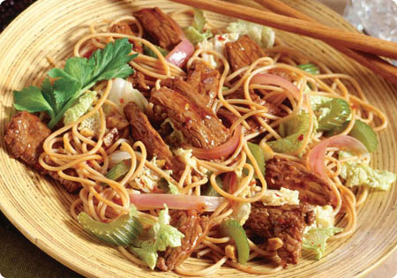
Peppered steak strips with oriental-style vegetables and noodles
Servings: 4
Preparation Time: 30 minutes
INGREDIENTS
4 portions spaghetti (about 8 oz uncooked)
4 portions lean steak (about 1 lb)
1/8 tsp crushed red pepper flakes
3 cloves garlic, minced
1 onion, sliced
4 celery stalks, sliced
1 head napa cabbage, shredded
½ cup lite soy sauce
DIRECTIONS
- Prepare spaghetti according to its package directions; drain and set aside.
- While the spaghetti is cooking, slice steak lengthwise into 2-inch strips. Cut crosswise into 1/8-inch-thick slices.
- Lightly coat a large skillet or wok with cooking spray. Over medium-high heat, stir-fry red pepper flakes and garlic for 1 minute.
- Add the steak strips to the skillet, stir-fry just until no longer pink, approximately 2 minutes. Remove the steak from skillet and set aside.
- Lightly recoat the skillet with cooking spray. Stir-fry onion and celery until tender, approximately 5 minutes. Add cabbage and cook until crisp-tender, approximately 2 more minutes.
- Return steak to the skillet. Add cooked spaghetti and lite soy sauce; mix gently and heat thoroughly.
- Divide into 4 portions, serve and enjoy!

Chicken Pomodoro
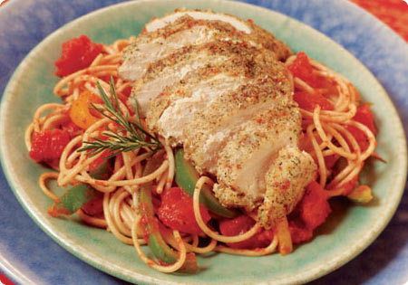
Succulent sautéed tomatoes with Italian-seasoned chicken and pasta
Servings: 4
Preparation Time: 30 minutes
INGREDIENTS
4 portions spaghetti (about 8 oz uncooked)
2 egg whites
4 tsp Mrs. Dash® Tomato-Basil-Garlic seasoning
½ cup reduced-fat Parmesan cheese, grated
4 portions chicken breast (about 1 lb)
2 Tbsp olive oil
3 tomatoes, diced (or one 15-oz can)
1 green bell pepper, sliced
1 yellow bell pepper, sliced
¾ tsp Italian seasoning
4 Tbsp red wine (or chicken broth)
DIRECTIONS
- Prepare spaghetti according to its package directions.
- In a medium mixing bowl, lightly beat the egg whites. In a pie plate, combine the Mrs. Dash seasoning and Parmesan cheese.
- Dip chicken breasts in egg whites then into the seasoned Parmesan, coating both sides.
- Heat olive oil in a large nonstick skillet over medium heat. Place chicken breasts in skillet; cover and cook for approximately 6 minutes; turn and cook for 6 more minutes until no longer pink in the center. Transfer the cooked chicken breasts to a plate; cover with foil to keep warm.
- Add tomatoes and bell peppers to skillet and sauté over medium heat until the peppers begin to soften, approximately 3 minutes. Stir in Italian seasoning and red wine, continue to cook for 2 minutes.
- Add pasta to the skillet with sautéed tomatoes and peppers; mix gently.
- Slice cooked chicken. Divide pasta mixture into four portions, top with a portion of sliced chicken, serve and enjoy!

Spaghetti and Meatballs
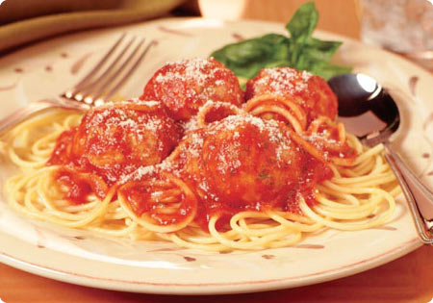
Hearty turkey meatballs in a rich Italian tomato sauce over traditional spaghetti
Servings: 6
Preparation Time: 40 minutes
INGREDIENTS
6 portions lean ground turkey (about 1 ½ lbs)
2 egg whites
½ cup dry breadcrumbs
¼ cup water
½ onion, finely chopped
2 cloves garlic, minced
¼ cup fresh parsley, minced
2 tsp dried basil
1 tsp ground black pepper
3 cups low-fat marinara pasta sauce
6 portions spaghetti (about 12 oz uncooked)
¼ cup reduced-fat Parmesan cheese
DIRECTIONS
- Preheat oven broiler.
- In a large mixing bowl, combine turkey, egg whites, breadcrumbs, water, onion, garlic, parsley, basil and black pepper. Mix ingredients thoroughly and then shape into 1 ½-inch diameter meatballs.
- Arrange meatballs on a baking sheet and place under broiler for 10 to 12 minutes, turning occasionally until they are browned on all sides.
- In a large saucepan, combine pasta sauce and cook meatballs. Simmer over low heat until warmed thoroughly, about 20 minutes.
- While the pasta sauce is simmering, prepare spaghetti according to its package directions.
- Place a portion of spaghetti on each plate, cover with a portion of meatballs and pasta sauce, then top with Parmesan cheese. Serve and enjoy!

Cool Taco Salad
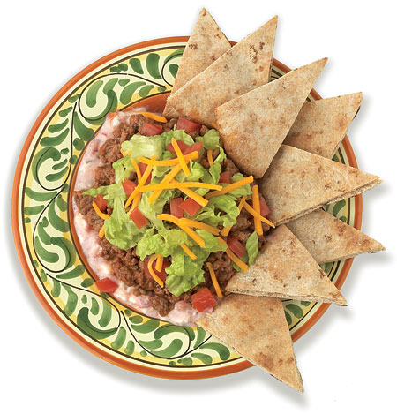
Taco-seasoned ground beef, lettuce and tomatoes with a creamy salsa dip
Servings: 2
Preparation Time: 20 minutes
INGREDIENTS
2 portions lean ground beef (about ½ lb)
1 Tbsp water
2 tsp taco seasoning mix, divided
2 whole-wheat pitas
2 Tbsp reduced-fat cream cheese, at room temperature
2 Tbsp fat-free sour cream
2 Tbsp salsa
1 cup lettuce, shredded
1 tomato, diced
¼ cup reduced-fat cheddar cheese, shredded
DIRECTIONS
- Preheat oven to 400° F.
- In a medium skillet, brown ground beef over medium heat until no longer pink; drain off any excess fat. Add water and 1 tsp taco seasoning to the beef and simmer for 3 minutes. Remove from heat and set aside to cool slightly.
- Cut each pita into 8 wedges and place on baking sheet. Bake for about 7 minutes or until lightly browned.
- While the beef is cooling, combine the remaining taco seasoning, cream cheese, sour cream and salsa in a small bowl; mix well. Divide and spread this mixture evenly on 2 small plates.
- Spoon a portion of the beef over the sour cream mixture, and top each with half the lettuce, tomato and cheddar cheese.
- Place 8 baked pita wedges on each plate, serve and enjoy!

Artichoke Chicken Salad
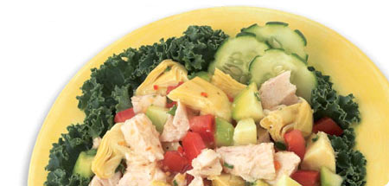
Artichoke hearts and chicken with tomato and cucumber in a light vinaigrette
Servings: 2
Preparation Time: 15 minutes
INGREDIENTS
2 cans (5 oz each) white meat chicken chunks, drained
1 can (14 oz) artichoke hearts in water, drained and sliced
1 tomato, diced
1 cucumber, peeled, seeded and diced
1 Tbsp fresh parsley, chopped
1 clove garlic, minced
Ground black pepper, to taste
¼ cup fat-free Italian dressing
6 lettuce leaves
DIRECTIONS
- In a large mixing bowl, combine chicken, artichoke hearts, tomato, cucumber, parsley, garlic and black pepper. Add Italian dressing; toss to coat.
- Place lettuce leaves on two separate plates. Divide chicken mixture into two portions and spoon over lettuce leaves. Serve and enjoy!

Chicken Pita Pizza
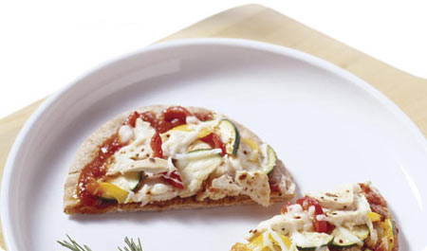
Homemade pizza for one topped with chicken, bell peppers, zucchini and melted mozzarella
Servings: 1
Preparation Time: 15 minutes
INGREDIENTS
1 whole-wheat pita
¼ cup low-fat pizza sauce
1 portion cooked chicken breast, sliced
¼ red bell pepper, sliced
¼ yellow bell pepper, sliced
¼ small zucchini sliced
¼ cup reduced-fat mozzarella cheese, shredded
DIRECTIONS
- Preheat oven to 425° F.
- Place the pita on a baking sheet. Spoon pizza sauce evenly over the pita. Top with the sliced cooked chicken, bell peppers, zucchini and mozzarella cheese.
- Bake for about 10 to 12 minutes or until the cheese is melted and the pizza is heated through.
- Slice, serve and enjoy!

Apple Tuna Salad
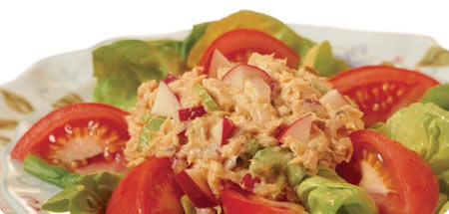
Tuna with crisp apple and celery on a bed of lettuce with fresh tomato wedges
Servings: 2
Preparation Time: 10 minutes
INGREDIENTS
1 can (6 oz) tuna, water packed, drained
½ onion, diced
1 stalk celery, sliced
1 Tbsp dill relish
1 tsp spicy brown mustard
2 Tbsp fat-free mayonnaise
1 apple, cored and diced
4 cups lettuce leaves
2 tomatoes, cut in wedges
DIRECTIONS
- In a medium mixing bowl, combine tuna, onion, celery, relish, mustard, mayonnaise and apple; mix well.
- Divide lettuce and tomato wedges between two separate plates. Top with a portion of tomato mixture, serve and enjoy!

Zesty Italian Chicken
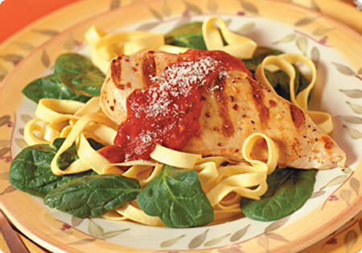
Chicken marinated in Italian dressing over fettuccine and fresh spinach
Servings: 2
Preparation Time: 50 minutes
INGREDIENTS
2 portions chicken breast (about ½ lb)
¼ cup fat-free Italian dressing
2 portions fettuccine (about 4 oz uncooked)
1 cup low-fat pasta sauce
2 cups baby spinach leaves
2 Tbsp reduced-fat Parmesan cheese, grated
DIRECTIONS
- Marinate chicken breasts in Italian dressing for at least 30 minutes prior to cooking.
- Preheat grill to high. Prepare fettuccine according to its package direction.
- Place marinated chicken on hot grill and cook for about 6 minutes; turn and grill for about 6 more minutes, until no longer pink in the center.
- In a small saucepan, warm pasta sauce over medium heat.
- Divide spinach leaves between two separate plates. Layer portions of warm fettuccine and grilled chicken breasts over spinach leaves.
- Top with pasta sauce and Parmesan cheese, serve and enjoy!

Grilled Fish Soft Tacos
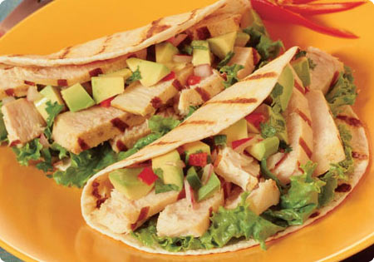
Tangy avocado salsa and grilled fish in a warm flour tortilla
Servings: 4
Preparation Time: 35 minutes
INGREDIENTS
1 Tbsp olive oil
4 limes, halved, divided
5 cloves garlic, minced, divided
2 tsp ground cumin, divided
4 portions swordfish or tuna (about 1 ½ lbs)
1 ripe avocado, peeled, pitted and diced
¼ red onion, minced
2 jalapeños, seeded and minced
2 Tbsp fresh cilantro, chopped
8 (6-inch) flour tortillas
6 lettuce leaves
DIRECTIONS
- Preheat grill to medium.
- Combine olive oil, juice of 3 limes, 4 garlic cloves and 1 tsp cumin in a shallow bowl or pie plate. Then add fish to this marinade and let it soak up the flavors for 15 minutes at room temperature, turning once after about 7 minutes.
- While fish is marinating, in a separate small mixing bowl, stir together the remaining lime juice, garlic and cumin with diced avocado, onion, jalapeños and cilantro.
- Place marinated fish on hot grill and cook for approximately 5 minutes, turn and grill for approximately 5 more minutes, until opaque throughout. Place cooked fish on a cutting board, let it cool slightly, then slice into thin strips.
- While the grill is still hot, place tortillas directly on it and grill them for about 30 seconds on each side.
- Place two tortillas on each plate. Put a lettuce leaf in each tortilla, fill with a portion of grilled, sliced fish, and top with tangy avocado salsa. Fold the tortillas over, serve and enjoy!

Balsamic Salmon Salad
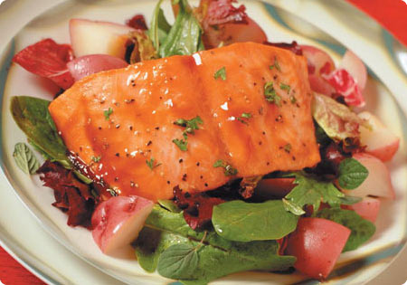
Broiled salmon fillet glazed with teriyaki marinade over balsamic salad and new potatoes
Servings: 2
Preparation Time: 30 minutes
INGREDIENTS
2 portions new potatoes, cubed
1 Tbsp teriyaki marinade
2 cloves garlic, minced
1 Tbsp fresh parsley, minced
2 portions salmon fillets (about 12 oz)
4 cups mixed salad greens
1 Tbsp fresh basil leaves, chopped
1 Tbsp fresh oregano leaves, chopped
1 Tbsp olive oil
2 Tbsp balsamic vinegar
1 lemon, halved
Freshly ground black pepper, to taste
DIRECTIONS
- Steam cubed new potatoes in a covered saucepan until tender, approximately 20 minutes.
- While potatoes are cooking, mix teriyaki marinade, garlic and parsley in a small bowl.
- Preheat broiler. Lightly coat a broiler pan with cooking spray. Place salmon fillets on the pan, skin-side down, and brush with teriyaki marinade.
- Broil salmon approximately 6 inches from the broiler until the fish is cooked through and flakes easily with a fork, about 8 to 10 minutes.
- While salmon is cooking, combine salad greens, basil, oregano, olive oil and balsamic vinegar in a medium bowl and toss.
- Divide tossed salad between two separate plates. Layer portions of potatoes and broiled salmon fillets over salad greens.
- Top salmon and salad with a squeeze of fresh lemon and freshly ground black pepper, serve and enjoy!

Baked Chicken Parmesan
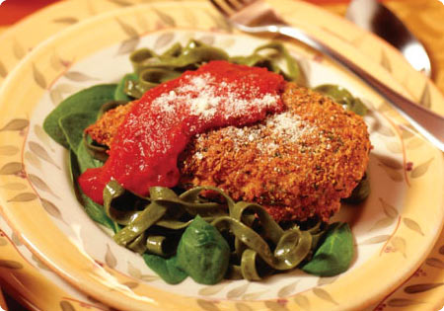
Spinach fettuccine with breaded chicken breast, topped with pasta sauce and Parmesan cheese.
Serving: 2
Preparation Time: 40 minutes
INGREDIENTS
2 egg whites
1/3 cup Italian-seasoned breadcrumbs
4 Tbsp reduced-fat Parmesan cheese, grated, divided
2 portions chicken breast (about ½ lb)
2 portions spinach pasta (about 4 oz uncooked)
1 cup low-fat pasta sauce
2 cups baby spinach leaves
DIRECTIONS
- Preheat oven to 400° F.
- In a medium mixing bowl, beat egg whites with fork until slightly frothy. Then, mix breadcrumbs and 2 tablespoons of reduced-fat Parmesan cheese in a pie plate.
- Dip chicken breasts in egg whites and then into the breadcrumb mixture, coating both sides.
- Lightly coat a baking sheet with cooking spray. Place chicken breasts on the baking sheet; bake for approximately 12 minutes, turn over and bake approximately 12 more minutes, until chicken is no longer pink in the center and coating is golden brown.
- While the chicken is baking, prepare spinach pasta according to its package directions.
- In a small saucepan, warm pasta sauce over medium heat.
- Divide spinach leaves between two separate plates. Layer portions of warm spinach pasta and baked chicken breasts over spinach leaves. Top with pasta sauce and remaining Parmesan cheese. Serve and enjoy!

Banana Cream Pudding

Protein- and vitamin-enriched banana cream pie filling
Servings: 2
Preparation Time: 25 minutes
INGREDIENTS
1 cup cold skim milk
1 packet vanilla Right® Light
2 Tbsp fat-free, sugar-free banana instant pudding mix
1 banana, sliced
½ cup Cool Whip® Free
DIRECTIONS
- Pour skim milk in blender. Then add Right® powder and blend on medium speed for 15 seconds.
- Add pudding mix and blend on high speed until thick and creamy, about 45 more seconds (stopping blender to stir with spoon and scrape down sides as needed).
- Spoon into 2 dessert glasses and chill in refrigerator for at least 20 minutes.
- Top each serving with half the banana slices and a dollop of Cool Whip®. Serve and enjoy!

Pina Colada

Tempting tropical taste with sultry and satisfying nutrition!
Servings: 1
Preparation Time: 3 minutes
INGREDIENTS
12 oz cold water
1 packet vanilla Right® Light
1/2 cup unsweetened pineapple chunks
1/4 tsp coconut extract
6 ice cubes
DIRECTIONS
- Pour cold water in blender. Then add Right® powder and blend on medium speed for 15 seconds.
- Add pineapple chunks and coconut extract; blend for 30 more seconds. Add ice cubes and blend on high speed until smooth, about 30 more seconds.
- Pour into a tall glass, serve and enjoy!

Strawberry Banana Smoothie
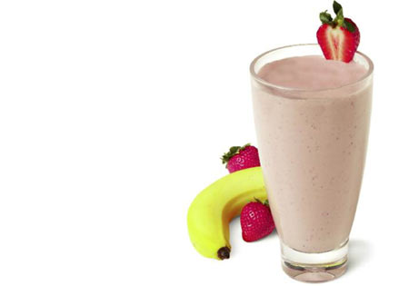
Sweet, smooth strawberries blended with banana and bursting with nutrition!
Servings: 1
Preparation Time: 3 minutes
INGREDIENTS
12 oz cold water
1 packet vanilla Right® Light
1 small banana
6 frozen strawberries
DIRECTIONS
- Pour cold water in blender. Then add Right® powder and blend on medium speed for 15 seconds.
- Add banana; blend for 30 more seconds. Add frozen strawberries and blend on high speed until smooth, about 30 more seconds.
- Pour into a tall glass, serve and enjoy!

